Akhilesh Anand

013714428

CMPE273

LAB3 REPORT

Architecture Diagram

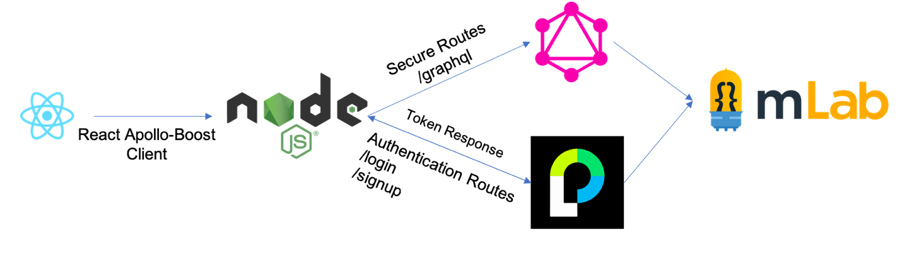

Summary:

* GraphQL is used in place of REST API’s for most of the routes.
* To maintain Session, JWT based token is sent back to user on authentication, but REST API’s are used to handle this.
* All Data is Stored in a mongo DB database hosted on mLab.
* Apollo-Boost Client is used to hit the graphql queries.

The purpose of building this application is to understand how to build a multipage REACTJS frontend and NODEJS Backend and understand Client Server Architecture. In addition to being able to store on a NoSQL Database, the project required the use of GraphQL that serves as a replacement to making REST based API Queries.

System Design

**DISCLAIMER: This Content remains same from LAB 2 with exception to the newer objectives that have been appended.**

### Frontend

* ReactJS rendering the markup and styled with CSS from Bootstrap Framework.
* JWT is used to maintain the Sessions
* React Routing is used, and components are swapped out where and when necessary.
* Redux is used to Maintain overall state of the React Application.
* Making use of the reusable nature of react components, many pages have been constructed by reusing components and uses data from Redux to populate information
* React Apollo Client is used to make queries to backend via GRAPHQL queries and mutations.

### Backend

* The Backend Runs on Nodejs.
* Since There is no routing required, the backend merely has to expose the methods to query the database and return response appropriately. This is achieved through ***Express*** a Node Module.
* GraphQL
* Passport is used to implement the JWT based Session Management.
* As Described by the project requirement, ***MongoDB*** is used to store data in the backend.
* Cross origin requests are enabled using the ***cors*** Module.

QUESTIONS

**An architecture for using multi-part data in GraphQL without using any open source library from Git.**

GraphQL on its own does not support Multipart data in its mutations out of the box. At least as of this writing.

The conventional way to approach this without any 3rd party open source libraries is to eliminate the need for multipart data by converting the data into Base64 encoded data and pass it along as the request body. This may not be the most elegant of solutions because of memory restrictions, not to mention the computational expense of encoding and decoding of said file, every single time.

The more sensible approach would be to handle file uploads separately in a different route and proceed with permitted data on graphql.

**State any open source library for enabling multi-part data transfer using GraphQL with sample code. Argue why do you think that this particular library is a good fit?**

An Interesting Library to handle multipart data In GraphQL is Jayden Seric’s ***graphql-upload*** This allows us to easily nest files into the graphql query and requires minimum invasion from the programmer’s perspective. It provides middleware that’s compatible with **Express**, which is what I have used as part of my Application.

Sample Code On Following Page

Server Side

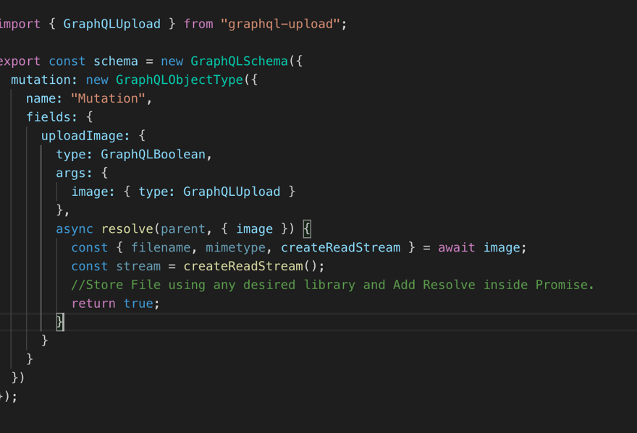

Integration With Express.

import { graphqlUploadExpress } from 'graphql-upload'

app.use("/graphql",

passport.authenticate("jwt", { session: false }),

graphqlUploadExpress({ maxFileSize: 10000000, maxFiles: 10 }),

graphqlHTTP({

schema,

graphiql: true

}));

Apollo Client Blob.

const gql = require('graphql-tag')

client.mutate({

mutation: gql`

mutation($file: Upload!) {

uploadFile(file: $file) {

success

}

}

`,

variables: { file }

})

Screen Captures

# Homepage

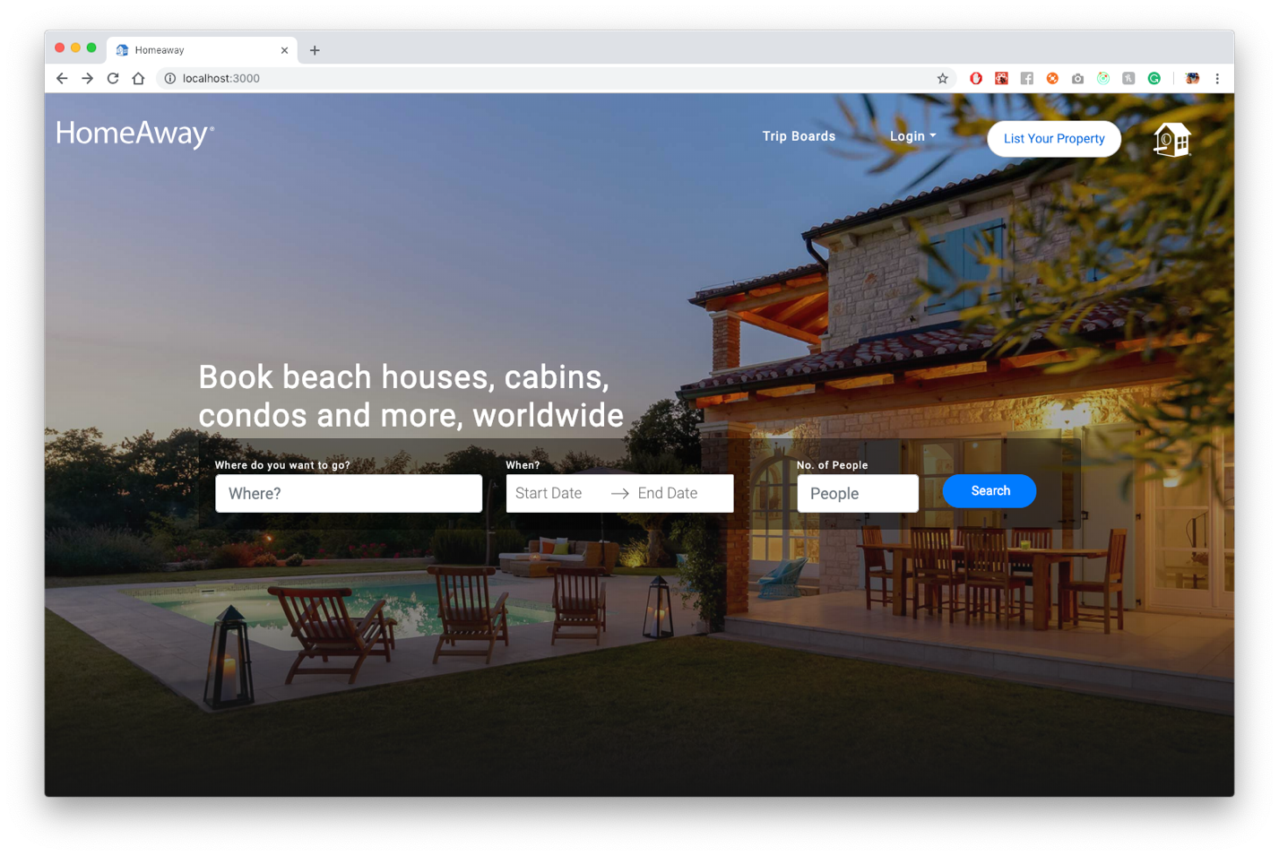

Search Route Detailed Later

# Traveler Login

## Before

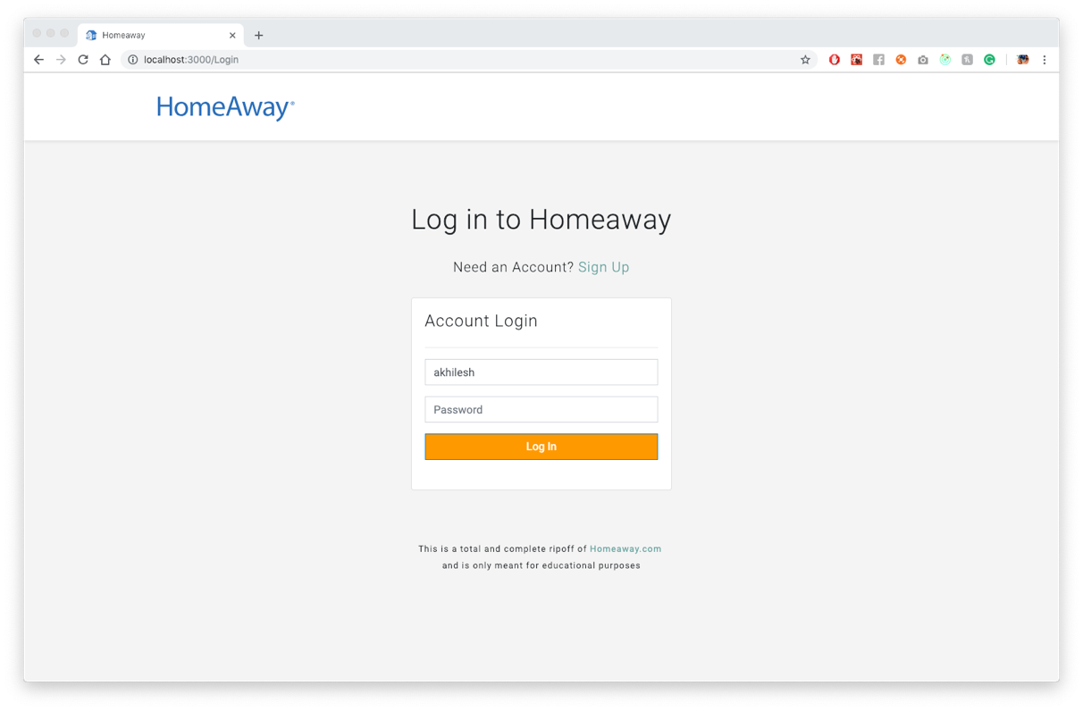

## After

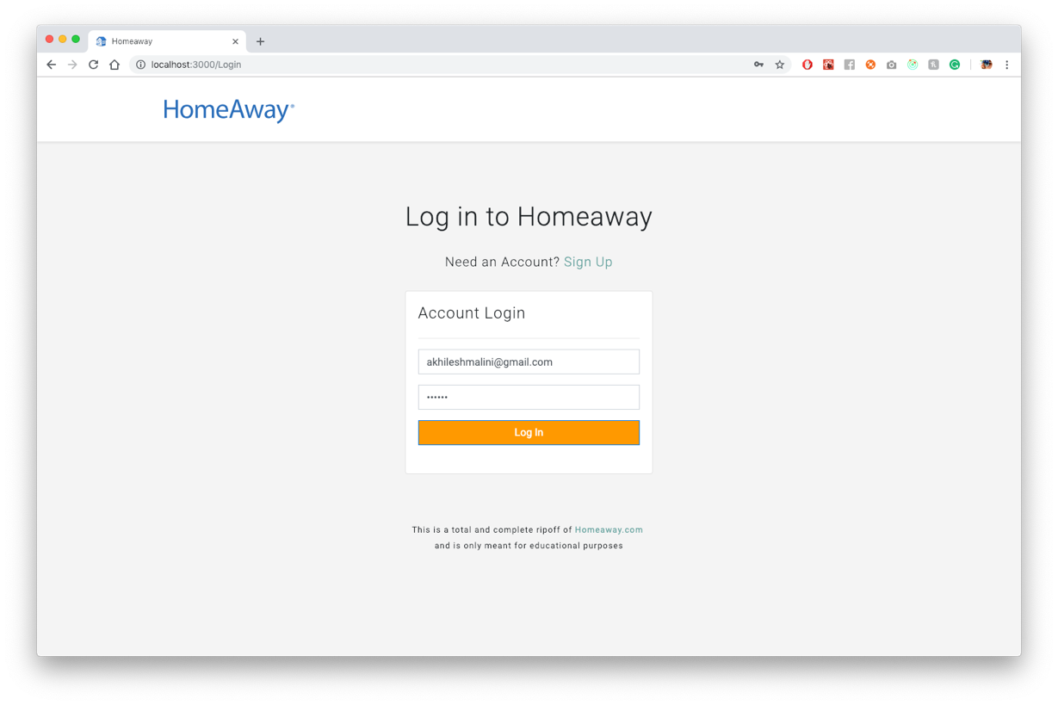

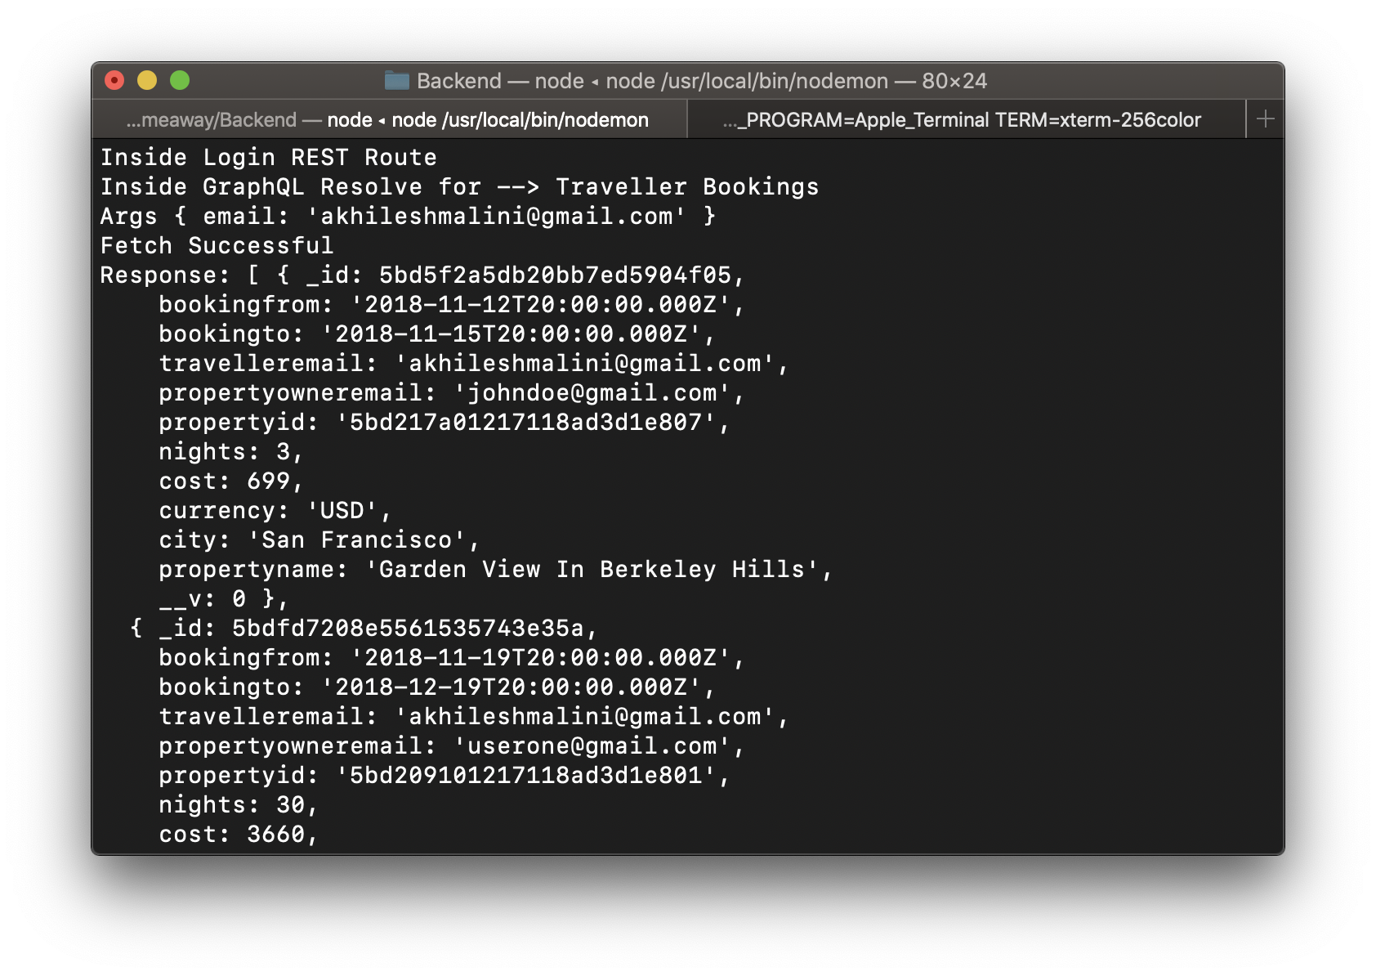

Automatically Redirects to Bookings After Login, Therefore, Get Traveler Bookings also found here

Backend

router.post("/login", async (req, res, next) => {

console.log("Inside Login REST Route");

passport.authenticate("login", async (err, user, info) => {

try {

if (err || !user) {

const error = new Error("An Error occured");

return next(error);

}

req.login(user, { session: false }, async error => {

if (error) return next(error);

const body = { _id: user._id, email: user.email };

const token = jwt.sign(

{ user: body },

"tobeornottobethatisthequestion",{

expiresIn: 7200

}

);

return res.json({ token });

});

} catch (error) {

return next(error);

}})(req, res, next);

});

Frontend

export function login(data) {

return async dispatch => {

try {

const res = await axios.post(`${ROOT_URL}/login`, data);

dispatch({

type: AUTHENTICATED,

payload: "User Logged in Sucessfully"

});

var base64Url = res.data.token.split(".")[1];

var base64 = base64Url.replace("-", "+").replace("_", "/");

var tok = JSON.parse(window.atob(base64));

localStorage.setItem("user", res.data.token);

localStorage.setItem("token_expiry", tok.exp);

localStorage.setItem("username", tok.user.email);

} catch (error) {

dispatch({

type: AUTHENTICATION_ERROR,

payload: "Invalid Email or Password"

});

}

};

# Sign-Up

## Before

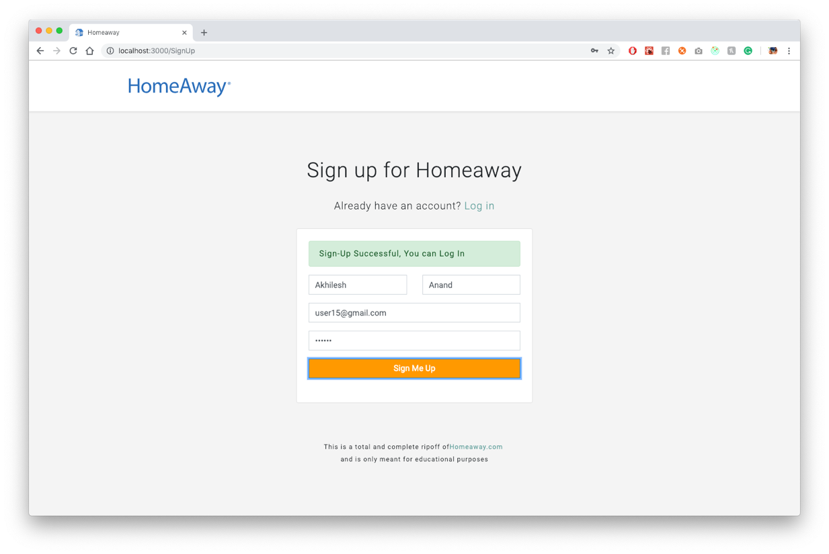

## After

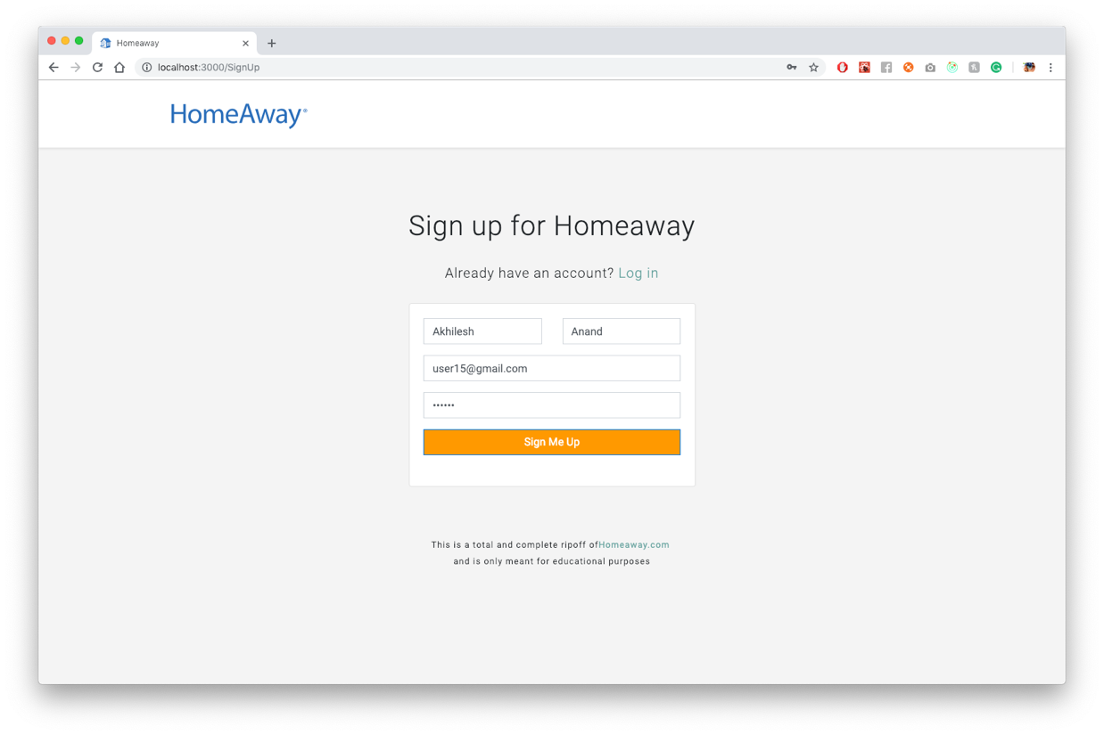

## Backend

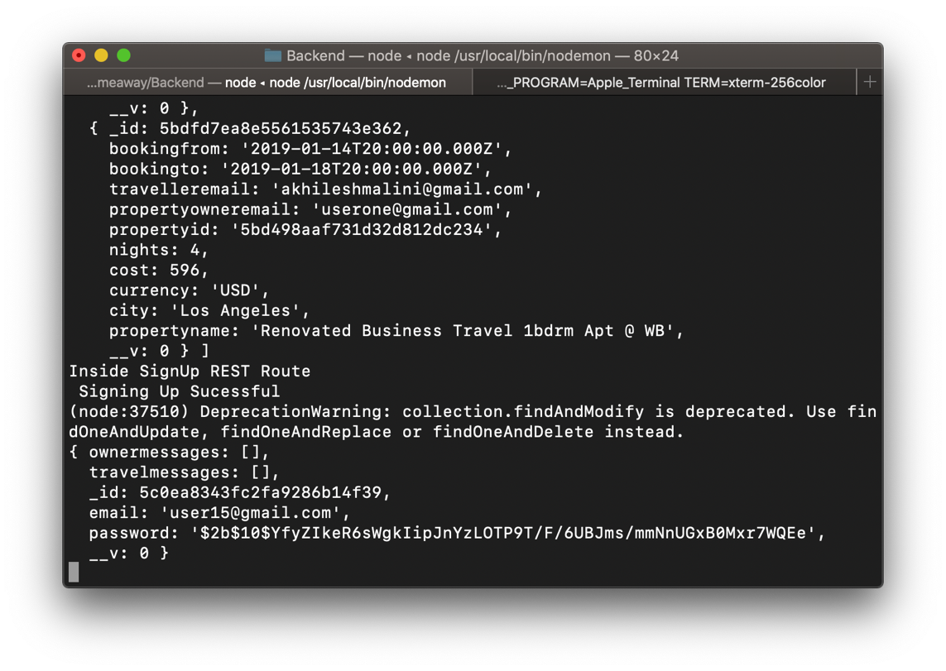

## Source Code

### Frontend

export function signUp(data) {

return async dispatch => {

axios.defaults.withCredentials = true;

axios.defaults.headers.common["Authorization"] =

"JWT " + localStorage.getItem("user");

await axios

.post(`${ROOT_URL}/signup`, data)

.then(response => {

if (response.status === 200) {

dispatch({

type: ADDED,

payload: "User Signed Up Sucessfully"

});

} else {

dispatch({

type: ADDING_ERROR,

payload: "An Error Occoured"

});

}

})

.catch(err => {

console.log(err);

dispatch({

type: ADDING_ERROR,

payload: "An Error Occoured"

});

});

};

}

### Backend

router.post("/signup", async (req, res, next) => {

console.log("Inside SignUp REST Route");

passport.authenticate("signup", { session: false }, (err, user, info) => {

if (err || !user) {

res.status(400).json({

message: "Sign-Up Unsuccessful",

success: false,

error: info

});

console.log("Error Signing Up");

} else {

console.log(" Signing Up Sucessful");

UserModel.findOneAndUpdate(

{ email: req.body.email },

{ $set: { fname: req.body.fname, lname: req.body.lname } },

(err, doc) => {

if (err) {

res.status(200).json({

message: "Sign-Up Partially Successful",

success: false,

user: err

});

} else {

console.log(doc);

res.status(200).json({

message: "Sign-Up Successful",

success: true,

user: req.user

});

}

}

);

}

})(req, res, next);

});

# Search Property

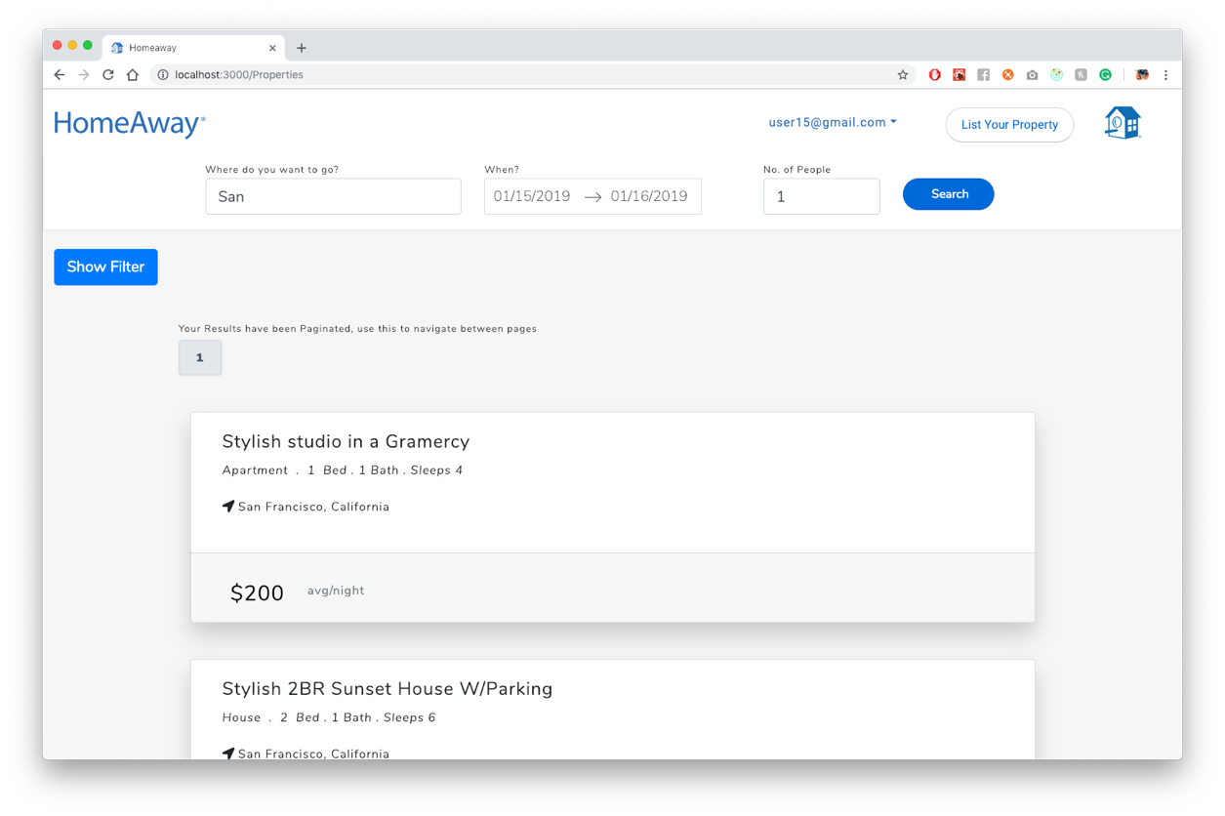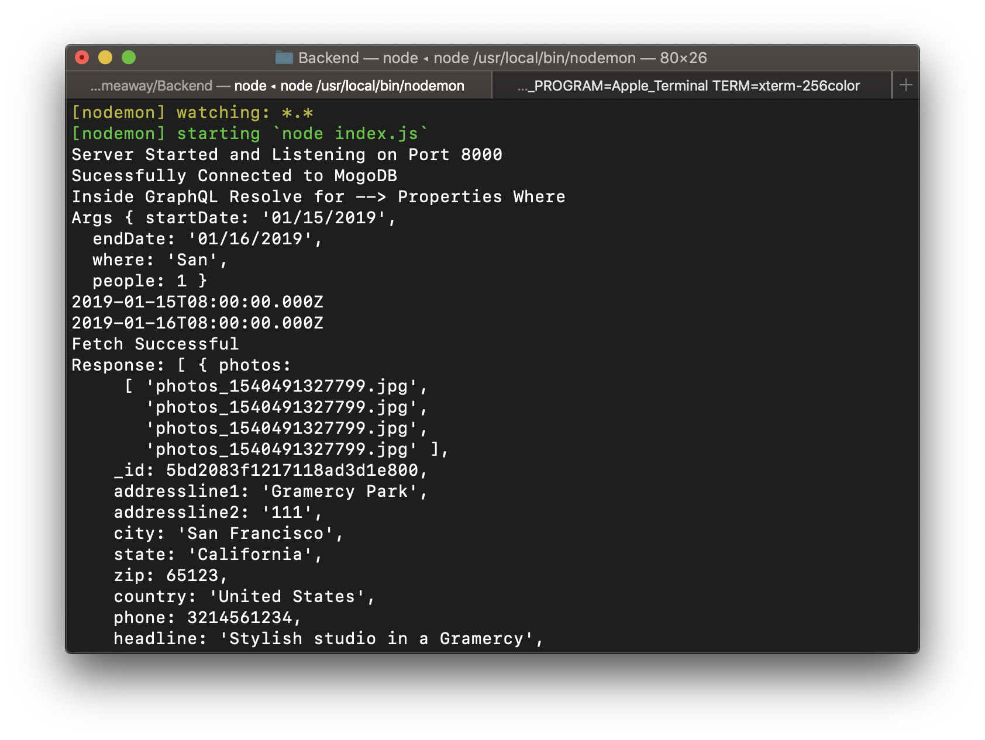

## Apollo Client Call

export function getPropertiesWhere(input) {

if (input.where !== "") {

return async dispatch => {

try {

var response = await client.query({

query: gql`{

propertiesWhere(startDate: "${input.startDate}", endDate: "${

input.endDate

}", where: "${input.where}", people: ${input.people}) {

headline

city

state

country

accomodates

bedrooms

bathrooms

bathrooms

minimumstay

baserent

currency

placetype

_id

}

}

`

});

console.log(response);

if (response.data.propertiesWhere.length === 0) {

dispatch({

type: SEARCH_BLANK,

payload: "No Properties Found"

});

} else {

dispatch({

type: SEARCH_PROPERTIES,

payload: response.data.propertiesWhere

});

}

} catch (error) {

dispatch({

type: SEARCH_PROPERTY_FETCH_ERROR,

payload: error

});

}

};

} else {

return {

type: SEARCH_BLANK,

payload: "No Properties Found"

};

}

}

## GraphQL Backend

propertiesWhere: {

type: new GraphQLList(PropertyType),

args: {

startDate: { type: GraphQLString },

endDate: { type: GraphQLString },

where: { type: GraphQLString },

people: { type: GraphQLInt }

},

resolve(parent, args) {

return new Promise((resolve, reject) => {

console.log("Inside GraphQL Resolve for --> Properties Where");

console.log("Args", args);

var startDate = moment(args.startDate, "MM/DD/YYYY").toDate();

var endDate = moment(args.endDate, "MM/DD/YYYY").toDate();

var where = args.where;

var people = args.people;

console.log(startDate);

console.log(endDate);

PropertyModel.find({

availablefrom: {

$lte: startDate

},

availableto: {

$gte: endDate

},

$or: [

{ city: { $regex: where, $options: "i" } },

{ state: { $regex: where, $options: "i" } },

{ country: { $regex: where, $options: "i" } }

],

accomodates: {

$gte: people

}

}).then(properties => {

console.log("Fetch Successful");

console.log("Response:", properties);

resolve(properties);

});

});

}

},

# Property View

Frontend

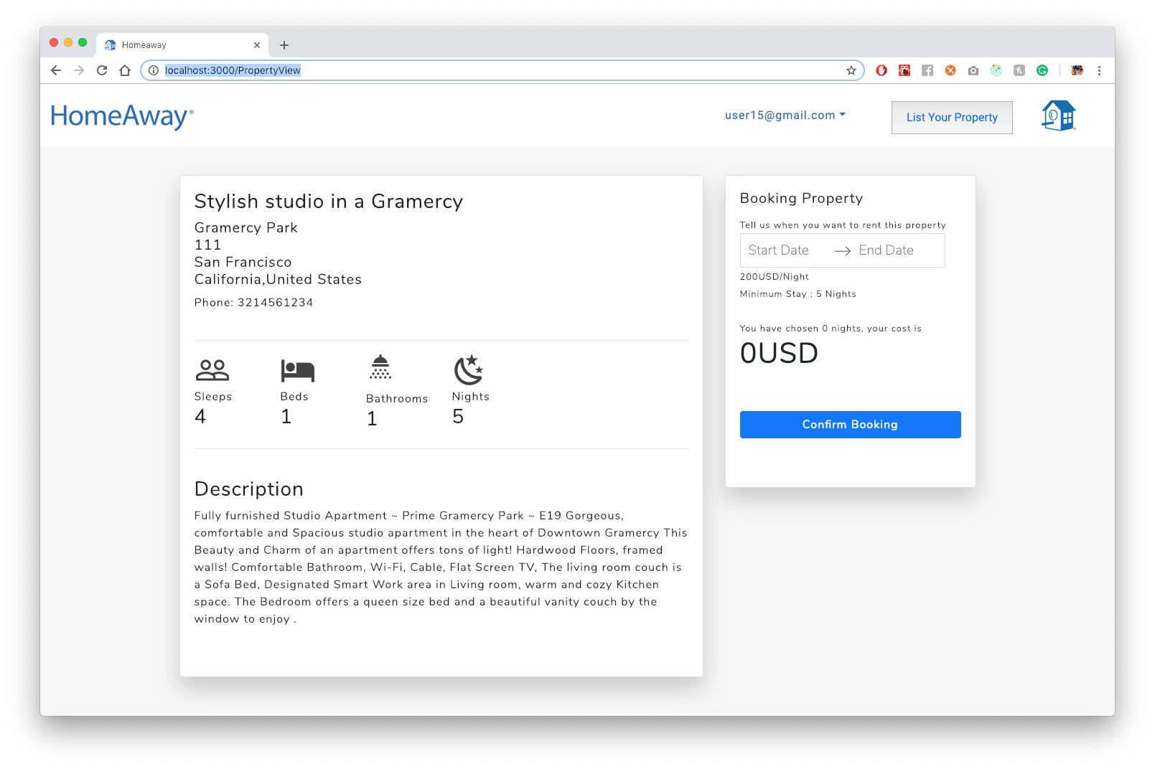

Backend

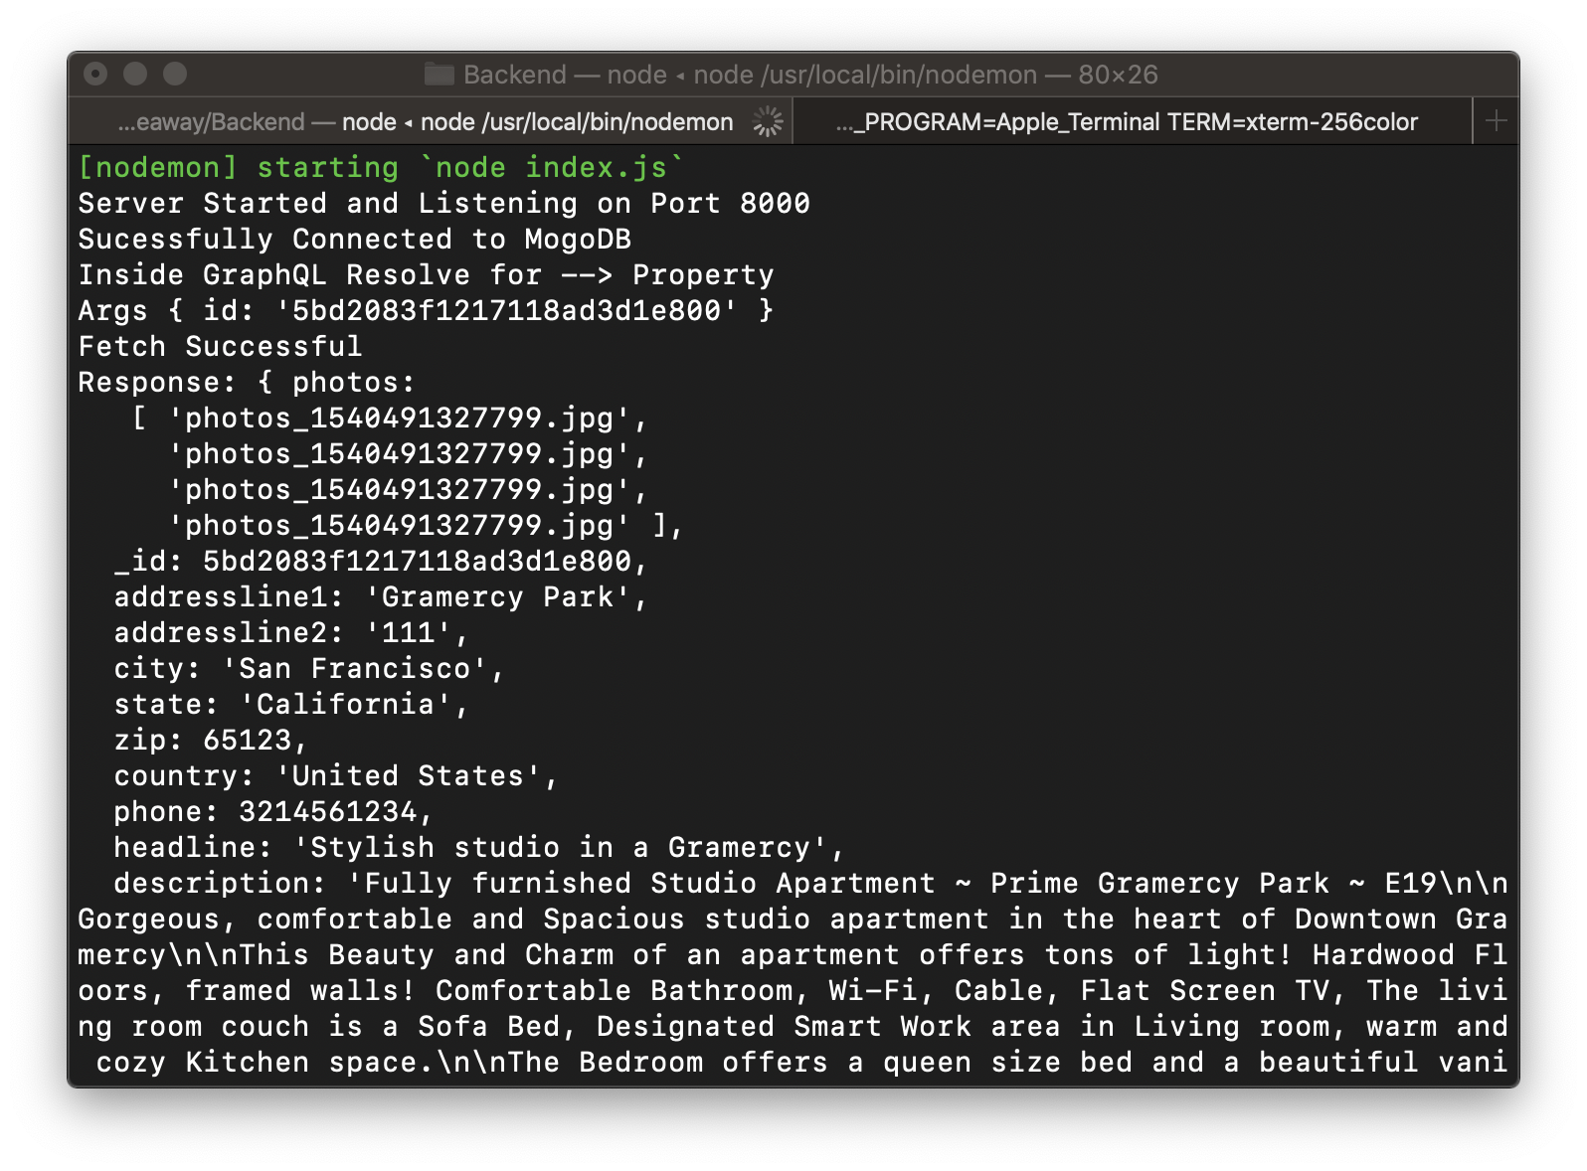

## Apollo Client Call

export function getProperty(id) {

return async dispatch => {

try {

var response = await client.query({

query: gql`{

property(id: "${id}") {

headline

addressline1

addressline2

city

state

zip

country

accomodates

bedrooms

bathrooms

minimumstay

description

phone

baserent

currency

availablefrom

availableto

}

}

`

});

dispatch({

type: PROPERTY,

payload: response.data.property

});

} catch (error) {

console.log(error);

dispatch({

type: PROPERTY_FETCH_ERROR,

payload: error

});

}

};

}

## GraphQL Backend

property: {

type: PropertyType,

args: { id: { type: GraphQLString } },

resolve(parent, args) {

return new Promise((resolve, reject) => {

console.log("Inside GraphQL Resolve for --> Property");

console.log("Args", args);

PropertyModel.findOne({ _id: args.id }).then(property => {

console.log("Fetch Successful");

console.log("Response:", property);

resolve(property);

});

});

}

},

# Booking

Choosing Dates

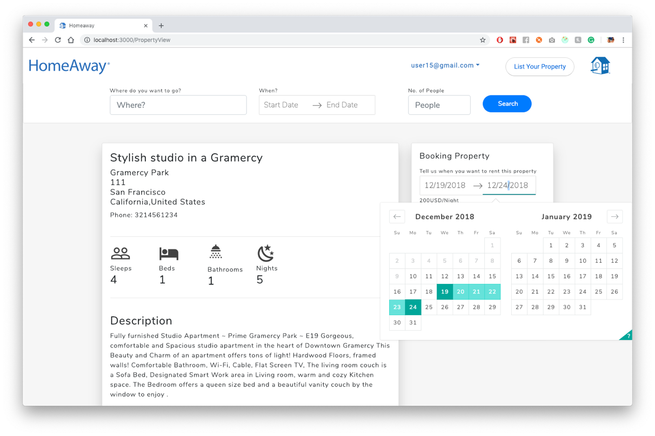

Confirming

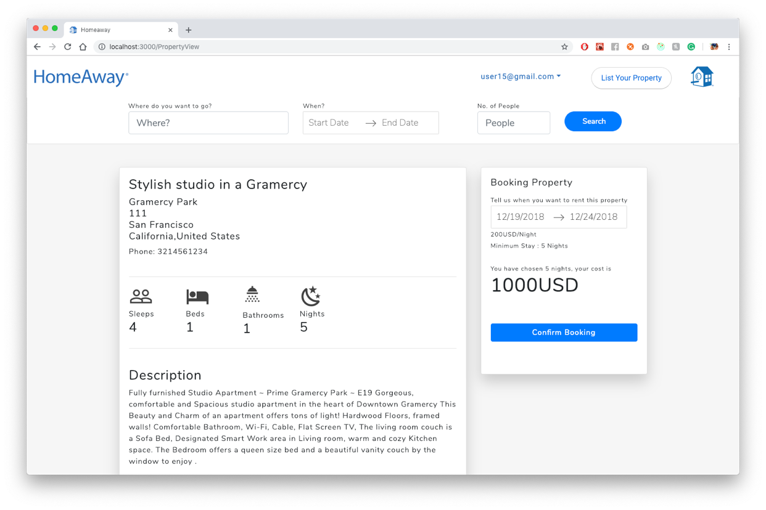

Booked Successfully

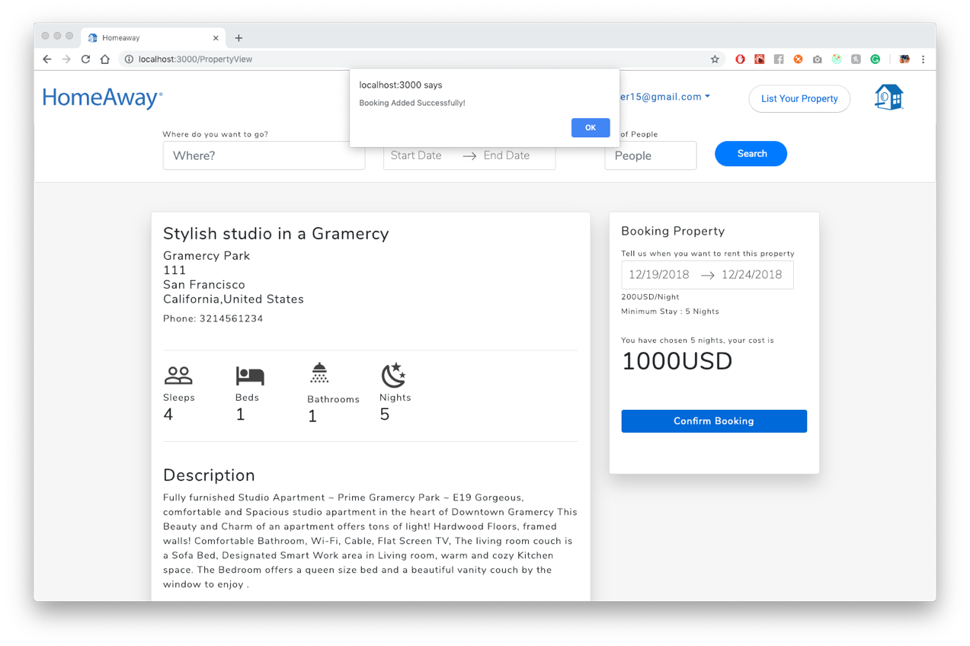

Bookings Shown on Dashboard

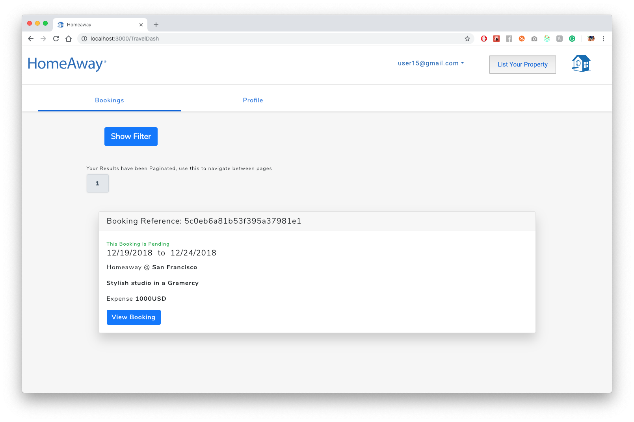

Backend Response

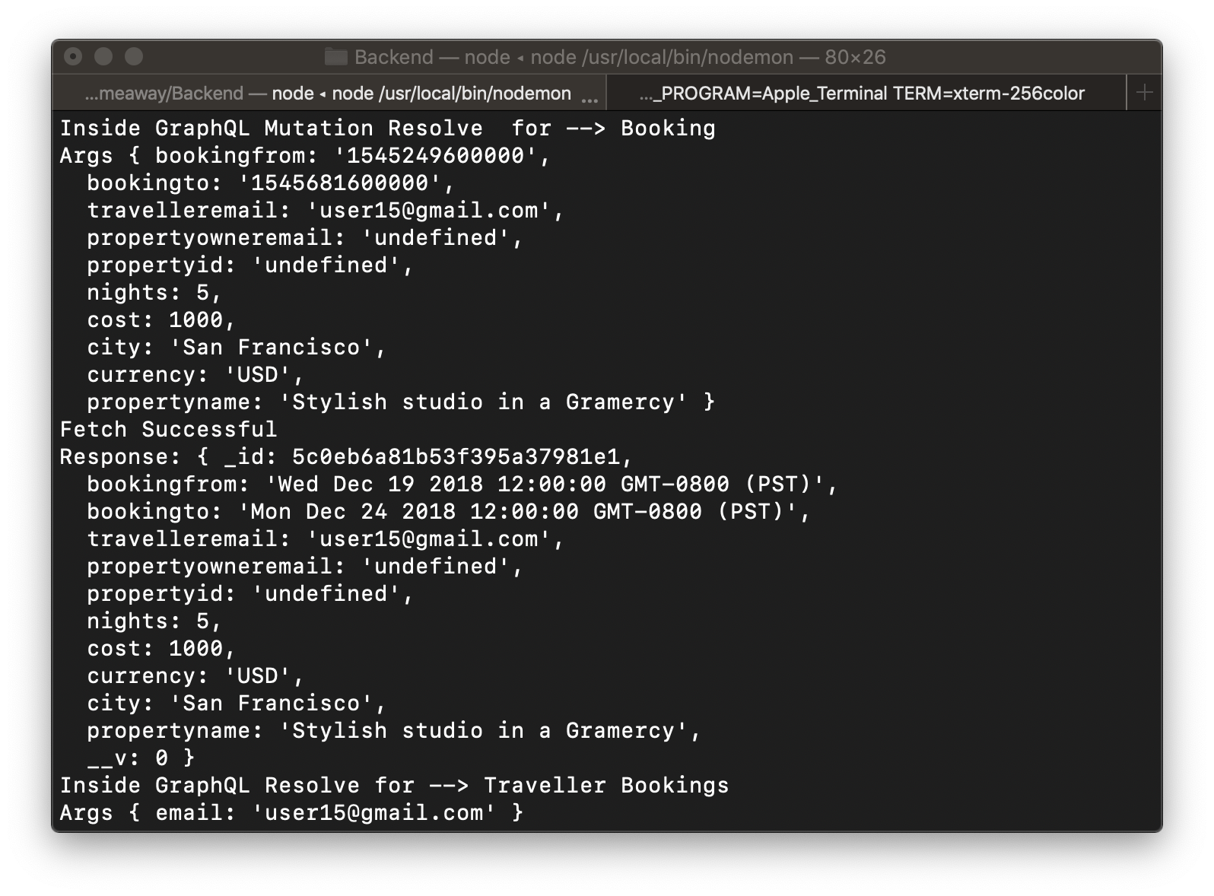

Backend Response for Dashboard Bookings Shown

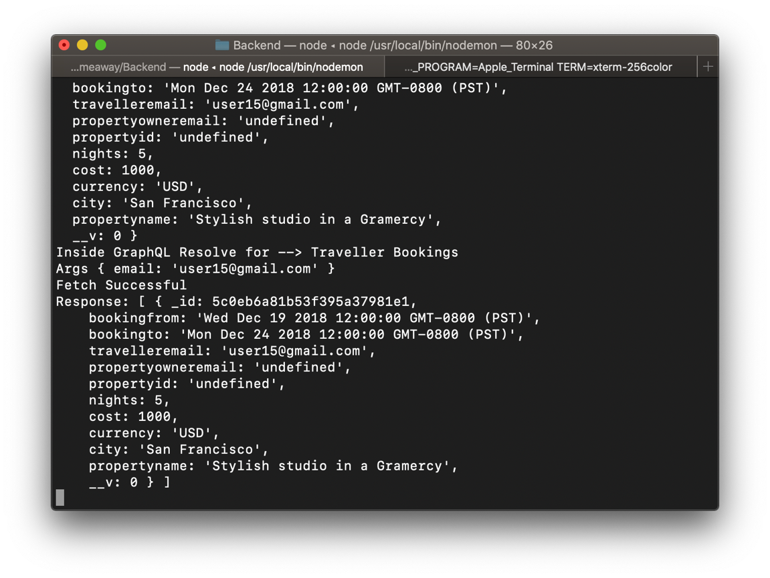

Apollo Client Calls

export function createNewBooking(data) {

console.log(data);

return async dispatch => {

try {

var response = await client.mutate({

mutation: gql`

mutation {

addBooking(

bookingfrom: "${data.bookingfrom}",

bookingto: "${data.bookingto}",

travelleremail: "${data.travelleremail}",

propertyowneremail: "${data.propertyowneremail}",

propertyid: "${data.propertyid}",

nights: ${data.nights},

cost: ${data.cost},

city: "${data.city}",

currency: "${data.currency}",

propertyname: "${data.propertyname}"

) {

bookingfrom

bookingto

travelleremail

propertyowneremail

propertyid

cost

city

currency

propertyname

}

}

`

});

console.log(response);

dispatch({

type: BOOKING_SUCCESS,

payload: "Booking Added SuccessFully"

});

} catch (error) {

dispatch({

type: BOOKING_FAILURE,

payload: error

});

}

};

}

export function getTravellerBookings(uemail) {

console.log("getTravellerBookings");

return async dispatch => {

try {

var response = await client.query({

query: gql`{

travellerBookings(email: "${uemail}") {

bookingfrom

bookingto

city

propertyname

cost

currency

propertyid

_id

}

}

`

});

dispatch({

type: TRAVELLER_BOOKING_SUCCESS,

payload: response.data.travellerBookings

});

} catch (error) {

dispatch({

type: TRAVELLERE_BOOKING_FAILURE,

payload: error

});

}

};

}

const Mutation = new GraphQLObjectType({

name: "Mutation",

fields: {

addBooking: {

type: BookingType,

args: {

bookingfrom: { type: GraphQLString },

bookingto: { type: GraphQLString },

travelleremail: { type: GraphQLString },

propertyowneremail: { type: GraphQLString },

propertyid: { type: GraphQLString },

nights: { type: GraphQLInt },

cost: { type: GraphQLInt },

city: { type: GraphQLString },

currency: { type: GraphQLString },

propertyname: { type: GraphQLString }

},

resolve(parent, args) {

var startDate = new Date(Number(args.bookingfrom));

var endDate = new Date(Number(args.bookingto));

return new Promise((resolve, reject) => {

console.log("Inside GraphQL Mutation Resolve for --> Booking");

console.log("Args", args);

BookingModel.create({

bookingfrom: startDate,

bookingto: endDate,

travelleremail: args.travelleremail,

propertyowneremail: args.propertyowneremail,

propertyid: args.propertyid,

nights: args.nights,

cost: args.cost,

currency: args.currency,

city: args.city,

propertyname: args.propertyname

}).then(book => {

console.log("Fetch Successful");

console.log("Response:", book);

resolve(book);

});

});

}

},

travellerBookings: {

type: new GraphQLList(BookingType),

args: {

email: { type: GraphQLString }

},

resolve(parent, args) {

return new Promise((resolve, reject) => {

console.log("Inside GraphQL Resolve for --> Traveller Bookings");

console.log("Args", args);

BookingModel.find({ travelleremail: args.email }).then(bookings => {

console.log("Fetch Successful");

console.log("Response:", bookings);

resolve(bookings);

});

});

}

},

# User Profile Update

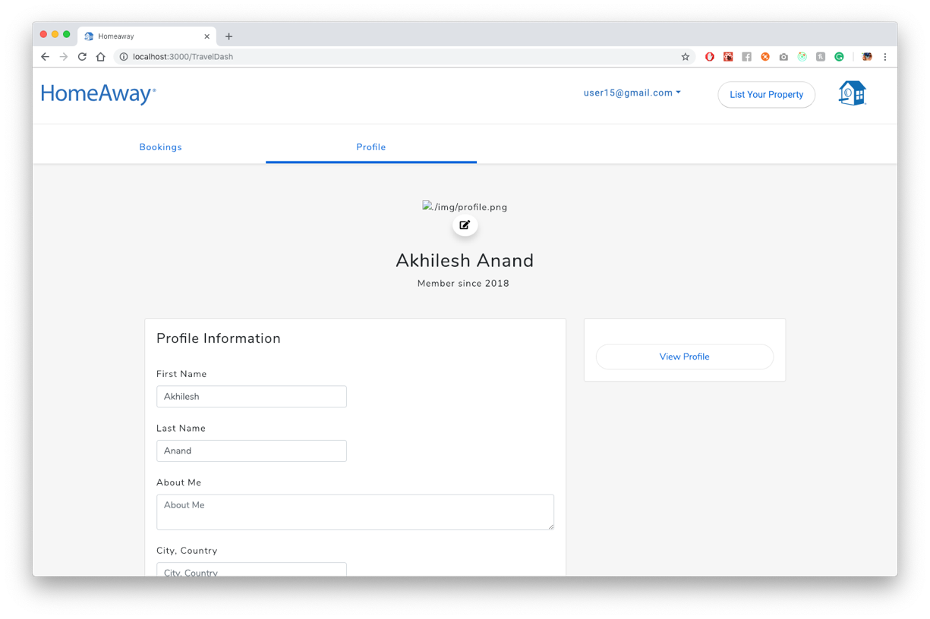

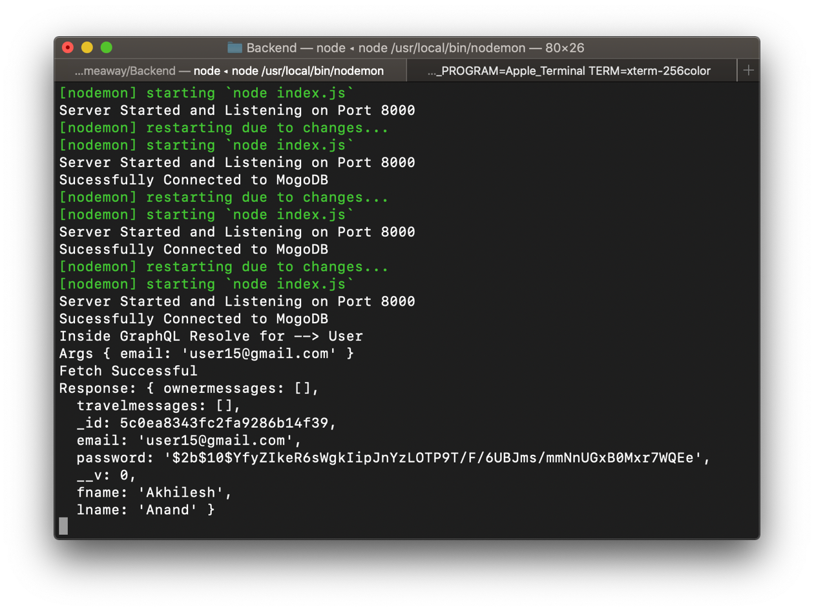

# CODE

updateUser: {

type: UserType,

args: {

email: { type: GraphQLString },

fname: { type: GraphQLString },

lname: { type: GraphQLString },

aboutme: { type: GraphQLString },

city: { type: GraphQLString },

school: { type: GraphQLString },

phone: { type: GraphQLString },

hometown: { type: GraphQLString },

languages: { type: GraphQLString },

gender: { type: GraphQLString },

propertyname: { type: GraphQLString }

},

resolve(parent, args) {

return new Promise((resolve, reject) => {

console.log("Inside GraphQL Mutation Resolve for --> Updating User");

console.log("Args", args);

const user = UserModel.findOneAndUpdate(

{ email: args.email },

{

fname: args.fname,

lname: args.lname,

aboutme: args.aboutme,

city: args.city,

school: args.school,

phone: args.phone,

hometown: args.hometown,

languages: args.languages,

gender: args.gender,

propertyname: args.propertyname

}

).then(user => {

console.log("Fetch Successful");

console.log("Response:", user);

resolve(user);

});

});

}

}

}

});

user: {

type: UserType,

args: { email: { type: GraphQLString } },

resolve(parent, args) {

console.log("Inside GraphQL Resolve for --> User");

console.log("Args", args);

return new Promise((resolve, reject) => {

UserModel.findOne({ email: args.email }).then(user => {

console.log("Fetch Successful");

console.log("Response:", user);

resolve(user);

});

});

}

},

# OWNER DASH BOARD

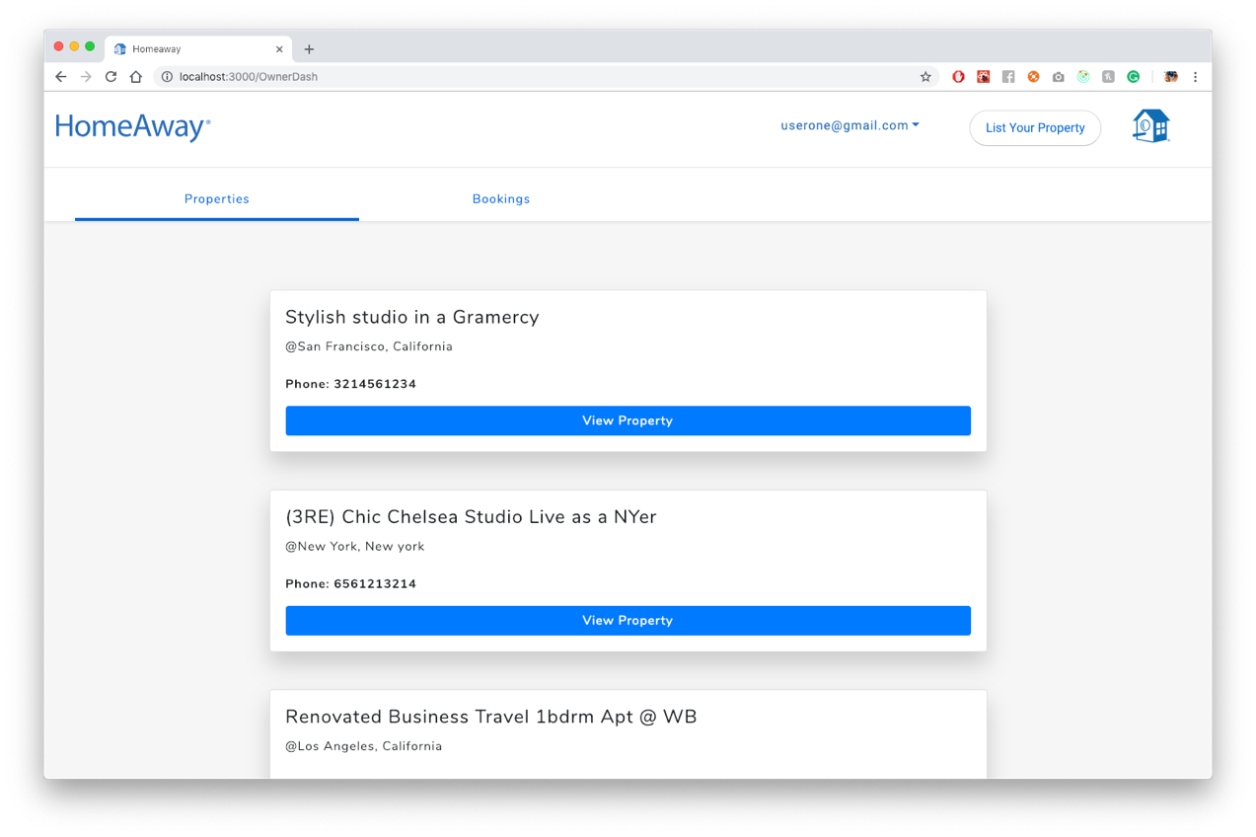

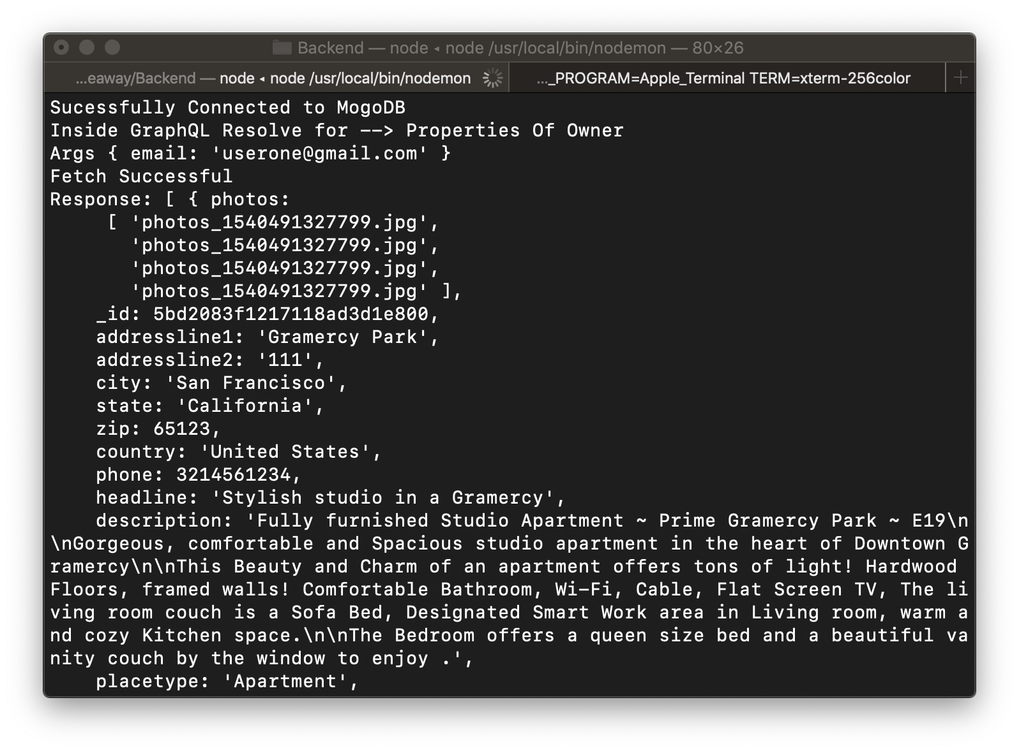

Backend GraphQL

propertiesOfOwner: {

type: new GraphQLList(PropertyType),

args: {

email: { type: GraphQLString }

},

resolve(parent, args) {

return new Promise((resolve, reject) => {

console.log("Inside GraphQL Resolve for --> Properties Of Owner");

console.log("Args", args);

PropertyModel.find({ email: args.email }).then(properties => {

console.log("Fetch Successful");

console.log("Response:", properties);

resolve(properties);

});

});

}

},

Frontend Apollo Client

export function getAllPropertiesOfUser() {

let uemail = localStorage.getItem("username");

return async dispatch => {

try {

var response = await client.query({

query: gql`{

propertiesOfOwner(email: "${uemail}") {

headline

city

state

phone

_id

}

}

`

});

console.log(response);

dispatch({

type: OWNER_PROPERTIES,

payload: response.data.propertiesOfOwner

});

} catch (error) {

dispatch({

type: OWNER_PROPERTIES_ERROR,

payload: error

});

}};}

# OWNER DASH BOARD BOOKINGS

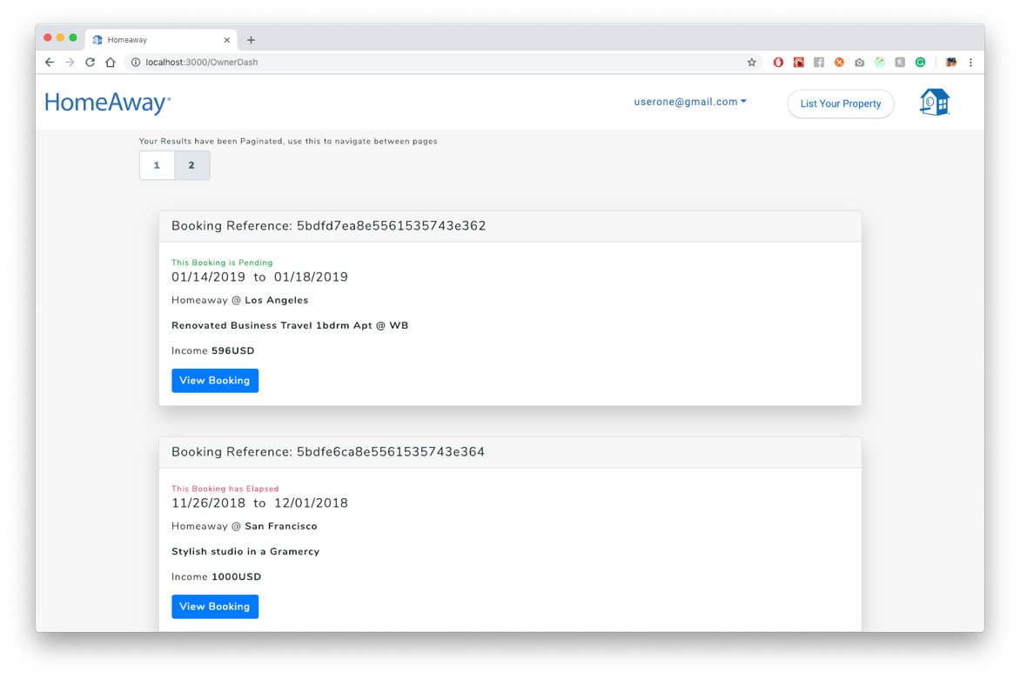

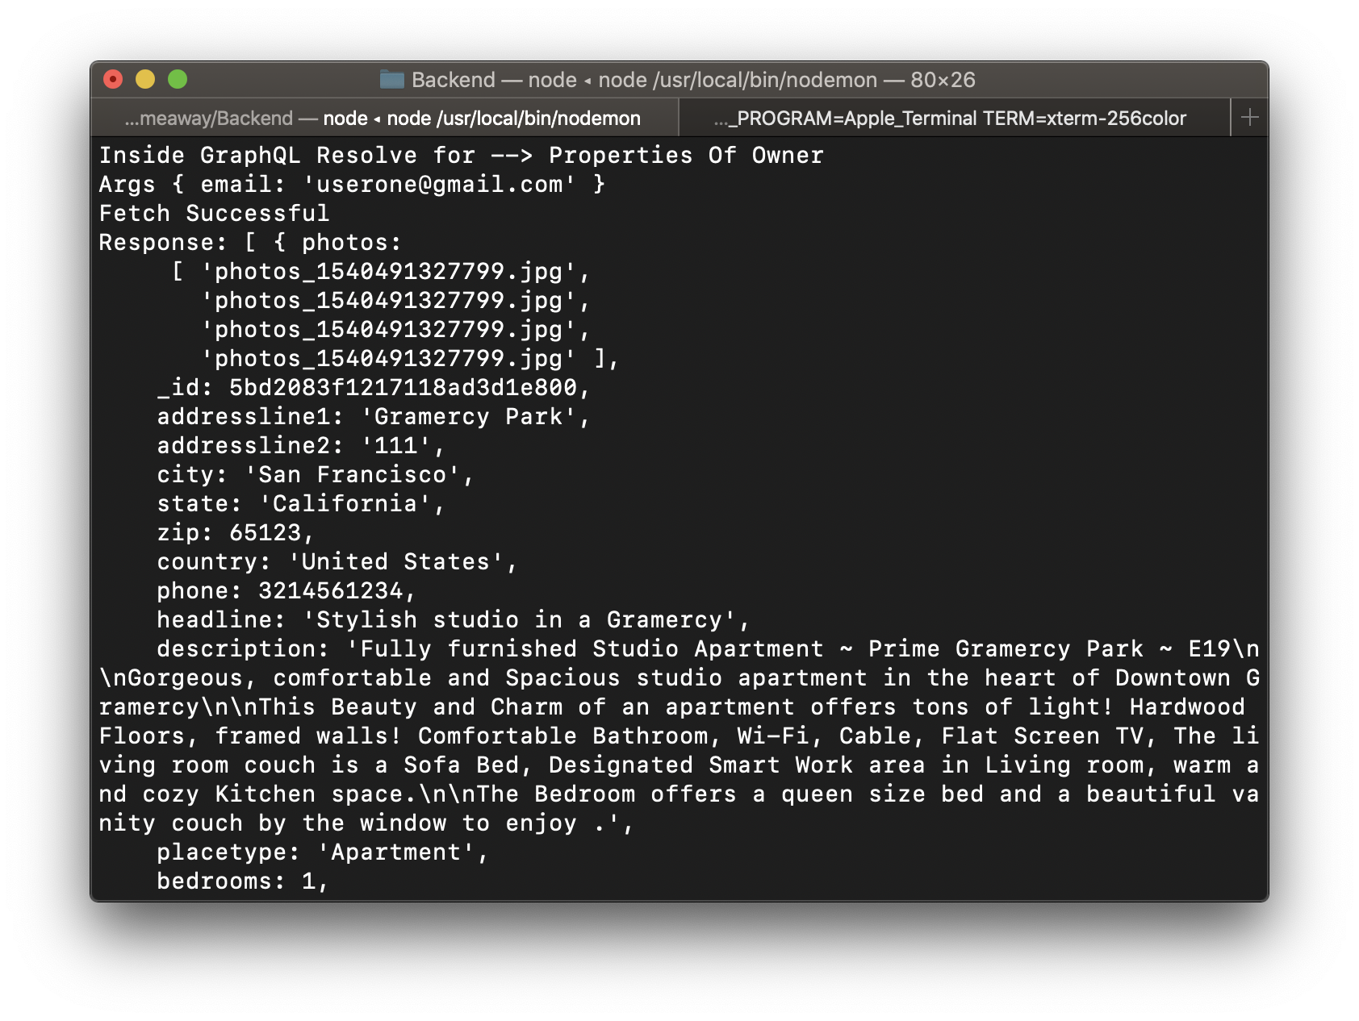

Backend GraphQL

ownerBookings: {

type: new GraphQLList(BookingType),

args: {

email: { type: GraphQLString }

},

resolve(parent, args) {

return new Promise((resolve, reject) => {

console.log("Inside GraphQL Resolve for --> Owner Bookings");

console.log("Args", args);

BookingModel.find({ propertyowneremail: args.email }).then(

bookings => {

console.log("Fetch Successful");

console.log("Response:", bookings);

resolve(bookings);

}

);

});

}

},

Apollo Client Call

export function getOwnerBookings(uemail) {

console.log("getOwnerBookings");

return async dispatch => {

try {

var response = await client.query({

query: gql`{

ownerBookings(email: "${uemail}") {

bookingfrom

bookingto

city

propertyname

cost

currency

propertyid

_id

}

}

`

});

dispatch({

type: OWNER_BOOKING_SUCCESS,

payload: response.data.ownerBookings

});

} catch (error) {

dispatch({

type: OWNER_BOOKING_FAILURE,

payload: error

});

}

};

}

# Viewing Booking

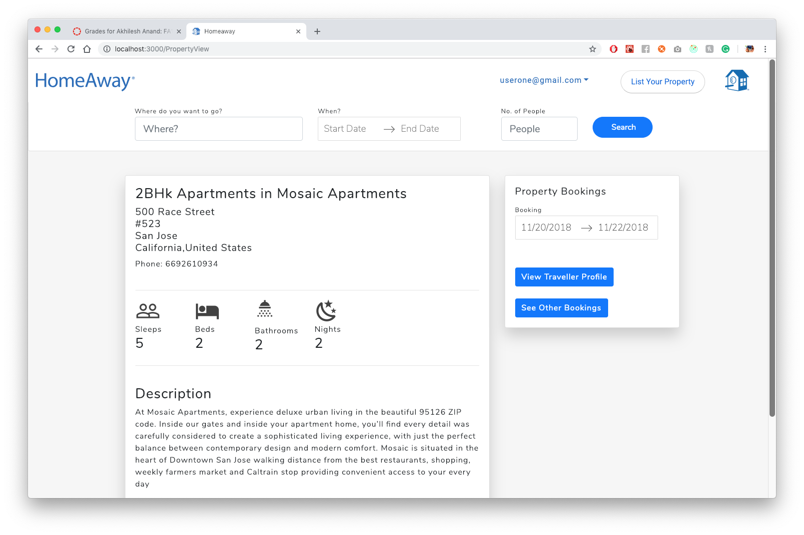

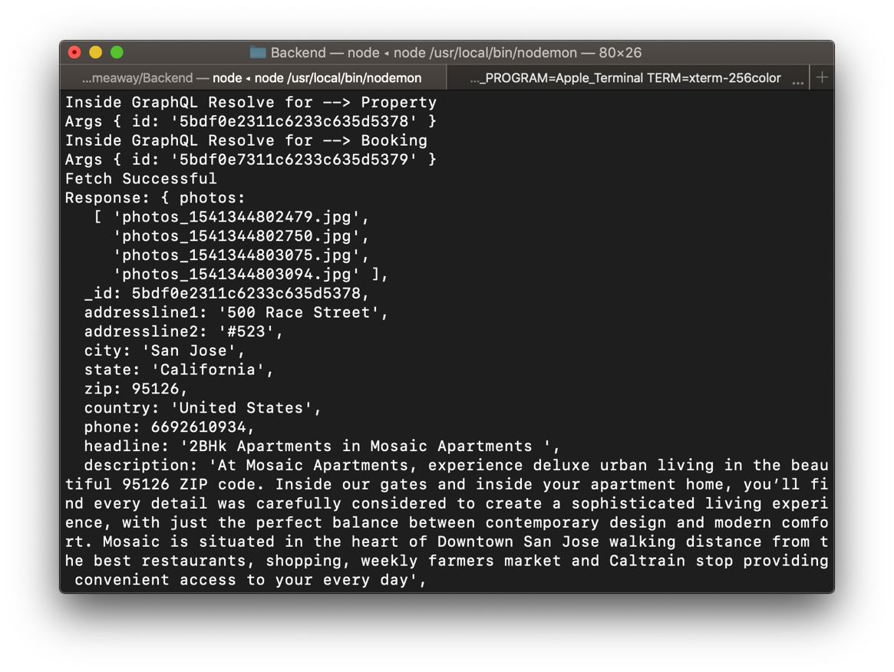

booking: {

type: new GraphQLList(BookingType),

args: {

id: { type: GraphQLString }

},

resolve(parent, args) {

return new Promise((resolve, reject) => {

console.log("Inside GraphQL Resolve for --> Booking");

console.log("Args", args);

BookingModel.find({ _id: args.id }).then(booking => {

console.log("Fetch Successful");

console.log("Response:", booking);

resolve(booking);

});

});

}

}

}

export function getProperty(id) {

return async dispatch => {

try {

var response = await client.query({

query: gql`{

property(id: "${id}") {

headline

addressline1

addressline2

city

state

zip

country

accomodates

bedrooms

bathrooms

minimumstay

description

phone

baserent

currency

availablefrom

availableto

}

}

`

});

dispatch({

type: PROPERTY,

payload: response.data.property

});

} catch (error) {

console.log(error);

dispatch({

type: PROPERTY_FETCH_ERROR,

payload: error

});

}

};

}